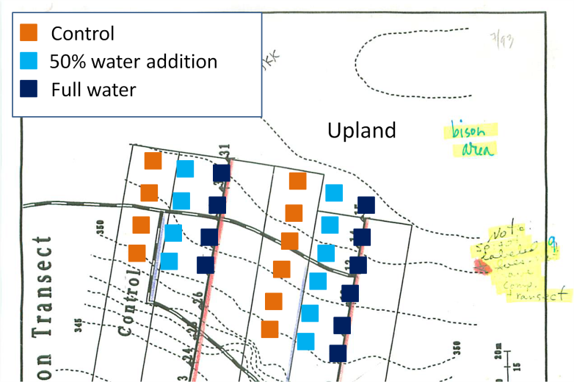
Belowground responses to 23 years of water addition – Kevin Wilcox, Alan Knapp
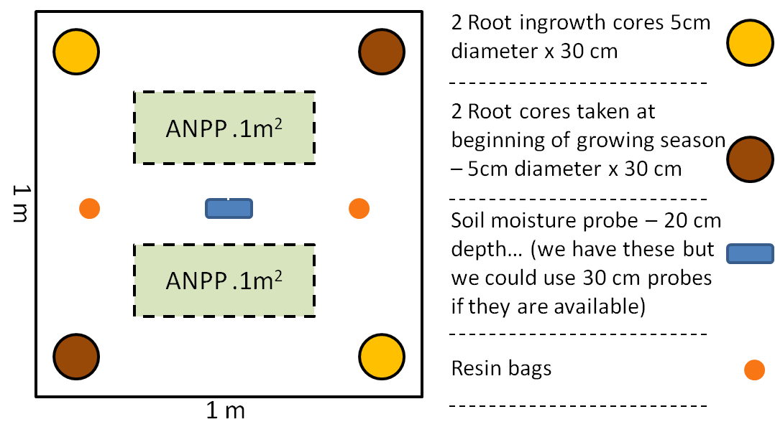
Background: Annual precipitation is forecast to change in majority of ecosystems globally (Weltzin et al. 2003, IPCC 2007) making long term ecosystem responses to changes in annual precipitation an important area of research. Much work has been done looking at the effects of precipitation on aboveground productivity (Sala et al. 1988, Huxman et al. 2004), but much less is known about belowground responses (Joslin et al. 2000, Gill and Jackson 2000). Fay et al. (2003) found no significant responses of root biomass to three years of more variable rainfall regimes even though there was a significant aboveground response. Because at the time of sampling this experiment was relatively short-term, this lack of significant change may indicate that standing crop root biomass will take longer to be significantly affected by changes in soil moisture and that longer termed experiments are needed to more fully understand the impact precipitation will have on belowground biomass. We are utilizing a long-term experiment (the irrigation transects) at the Konza Prairie Biological Station to examine the effects of 23 years (1991 – 2013) of irrigation on above and belowground productivity, vegetation nutrient content, and soil available nutrients to further our understanding of how mesic grassland systems may respond to climate change.
Figure 2. Plot design and placement of measurements in the Irrigation Transect at the Konza Prairie Biological Station, Manhattan, KS.
Figure 1. Proposed plot placement in the upland region of the Irrigation Transects at the Konza Prairie Biological Station, Manhattan, KS.
Methods: Existing experimental framework: The irrigation transects simulate increased precipitation to eliminate water limitation. Three treatment transects are irrigated via full-circle sprinkler heads elevated 1 m from the ground, while three control transects are not manipulated. Water is added semiweekly throughout the growing season (May-September), with the amount of water added varying such that the sum of the ambient and added rainfall equaled the estimated actual evapotranspiration (ET) throughout the growing season. The average amount of water added throughout the growing season between 1991 and 2012 was ca. 31% (262mm) of the mean annual precipitation during those years (847mm). Also, because of the way in which the sprinklers distribute water, there exists a gradient in the amount of water falling in an area depending on how far from the sprinkler head that area is.
Sampling design: I set up 30 temporary 1 m² plots in mid-May, 2013 to measure above- and belowground responses to long term water addition (Fig. 1 and 2). There were 10 replicates each of three treatments (full water addition, 50% water addition, and no water addition) in the upland portion of the irrigation transects (Fig. 1). Response variables measured were: belowground net primary productivity (BNPP), standing root biomass, available soil nitrogen, aboveground net primary productivity (ANPP), soil moisture (using data from existing probes for the 0 and 100% treatments and installing probes in the 50% treatment), and species composition. Root ingrowth cores were constructed using 2 mm screen formed into cylinders with a diameter of 5 cm and a depth of 30 cm. In mid-May, two ingrowth cores per plot were installed by augering a hole to 30 cm, inserting an empty mesh cylinder, and then filling with sieved soil from the site. In September of 2013, the two ingrowth cores were extracted, two soil cores (5 cm diameter x 30 cm depth; to estimate standing crop biomass) taken, and two 0.1 m² plots were clipped to estimate ANPP. Resin bags and soil moisture probes (in the 50% addition plots) were installed at the same time as ingrowth core installation.
Sample processing:
- ANPP: Dried at 60°C for 48 hours and weighed at Colorado State University (CSU).
- BNPP: Samples would then be separated into depth categories of 0-15 and 15-30 cm and sieved and decanted to separate out root biomass. Roots would be dried at 60°C for 48 hours, sorted, and weighed at CSU to estimate BNPP
- Belowground standing crop biomass: same as BNPP
- Soil available nitrogen: Resin bag extraction at CSU and samples potentially sent to Kansas State University (KSU) for nutrient analysis.
- Plant available nitrogen: plant samples (above and belowground) ground at CSU and potentially sent to KSU for nutrient analysis.

This sampling effort would (1) provide new insight into how US tallgrass prairies might respond belowground to increased annual precipitation and (2) be useful to accentuate and inform future research within the experimental framework of the Irrigation Transects.

